[Insert Date]

[School Name] Parents!

[School Name] is so excited to launch our new Shirt Sponsorship program! Through this program, we will be able to provide an item of spirit wear to EVERY student in our school, while also raising needed funds for our students, staff, and programs this year.
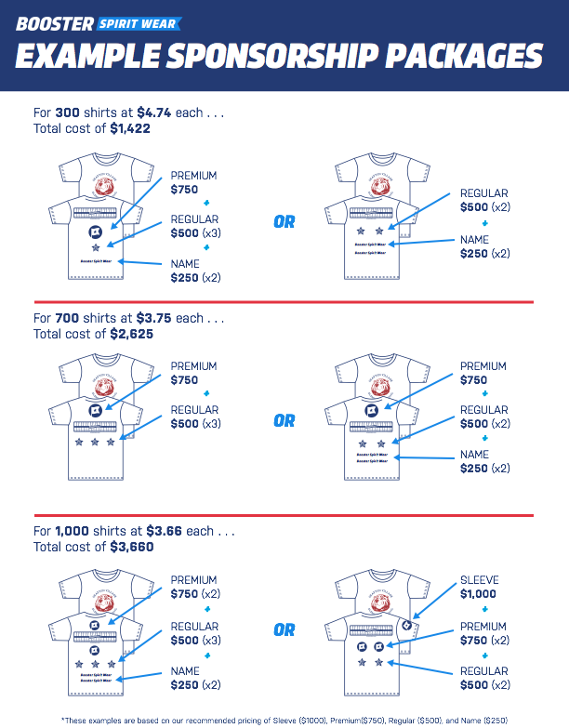
The primary component of our Shirt Sponsorship program is our Event Shirts. We are hoping to partner with local businesses to help sponsor these shirts. Their logo or name will be displayed on the back of the shirt, and worn by every student in our school. Not only will their support be incredibly helpful to [School Name], but it will enable us to support them as a community!
EXAMPLE LETTER/EMAIL TO PARENTS
EXAMPLE LETTER/EMAIL TO PARENTS
Use this version if you are asking for shirt sponsors for the first time.
Make sure to send out the Partnership Form with your email or letter.
If you know of, or are part of, a business that would be interested in becoming a [School Name] Shirt Sponsor, please see the attached Sponsorship Form for more information.
We need a commitment from all Sponsors by [Insert Date 1 week before your order deadline] in order to supply all our students with a shirt.
Thank you in advance for supporting our school! If you have any questions, please contact me at [Email Address].

Thank you,
[Contact Name]
[Title (Ex.: Spirit Wear Chairperson)]
[PTA/PTO/Organization]

[Insert Date]

[School Name] Parents!

[School Name] is so excited to launch our Shirt Sponsorship program! Through this program, we will be able to provide an item of spirit wear to EVERY student in our school, while also raising needed funds for our students, staff, and programs this year.
Last year, we were able to partner with some incredible businesses to provide custom shirts to all our students! We are hoping to partner with EVEN MORE local businesses this year. Their logo or name will be displayed on the back of the shirt, and worn by every student in our school. Not only will their support be incredibly helpful to [School Name], but it will enable us to support them as a community!
EXAMPLE LETTER/EMAIL TO PARENTS
EXAMPLE LETTER/EMAIL TO PARENTS
Use this version if you received shirt sponsors the previous year.
Make sure to send out the Partnership Form with your email or letter.
If you know of, or are part of, a business that would be interested in becoming a [School Name] Shirt Sponsor, please see the attached Sponsorship Form for more information.
We need a commitment from all Sponsors by [Insert Date 1 week before your order deadline] in order to supply all our students with a shirt.
I’d like to give one more shout out to last year’s sponsors! Thank you to the following partners for their generous support!
[List Business Names]

Thank you in advance for supporting our school! If you have any questions, please contact me at [Email Address].
Thank you,
[Contact Name]
[Title (Ex.: Spirit Wear Chairperson)]
[PTA/PTO/Organization]

